Week 31 Math homework
a) 31-1
It asks students to determine which picture is the correct answer based on the clue it gives them.
Line: 3 + 3 + 3 = 9
Row: 3 + 3 + 3 = 9
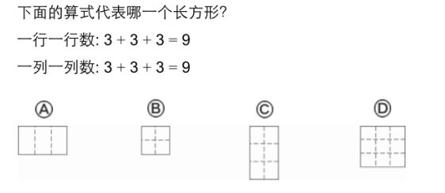

b) 31-2
Count by line: ________________________
Count by row: ________________________
How many squares are used to cover the rectangle? A: ____________ squares.
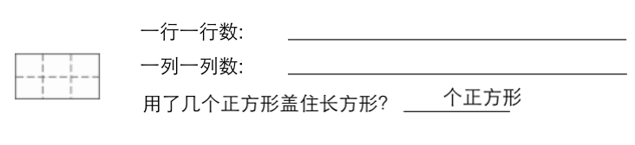

c) 31-3
How many parts are equal? Write down how many.
Circle “one half” “one third” or “one fourth (quarter)”
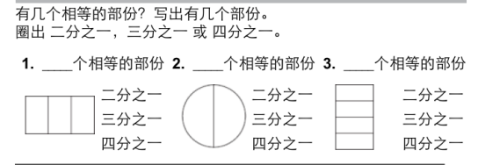
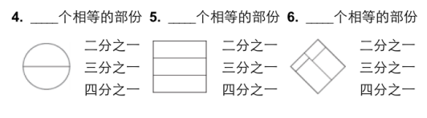
d) 31-4
Write down how many parts the shape has
Circle “equal” or “not equal”
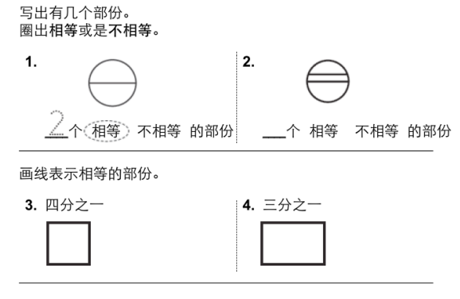

e) 31-5
Cross out the wrong answers and circle the right one.
1. What am I? I have 3 edges and 3 vertexes. I have equal length of edges.
2. What am I? I have more than 5 edges. I have equal length of edges.
3. What am I? I have 5 flat faces. You can use my flat faces to make a triangle and rectangle.
